FitBuddy – AI Fitness Plan Generator using Gemini Models
Project Description:
FitBuddy is a web-based application that uses AI to generate personalized workout plans and nutrition tips based on a user’s fitness goals, such as weight loss, muscle gain, or general wellness. Built with FastAPI and integrated with Google’s Gemini AI models, FitBuddy simplifies the process of creating structured and effective fitness routines.
The application takes in user information—like age, weight, goal, and preferred workout intensity—and generates a customized 7-day fitness plan. Users can also submit feedback to update and refine their plan using AI. A complementary nutrition or recovery tip is also provided based on their selected goal.
With a clean user interface and database support via SQLite, FitBuddy ensures each user's data and generated plan are stored and accessible. It offers both API endpoints and an interactive HTML interface for ease of use.
Scenarios:
Scenario 1 : A user inputs their personal details including name, age, weight, fitness goal (e.g., “weight loss” or “muscle gain”), and preferred workout intensity ( “high”, “medium” or “low”) to receive a personalized 7-day workout plan. The system generates a day-by-day schedule tailored to the user's fitness objective and experience level. This AI-driven customization enhances user motivation and adherence by providing structured and goal-specific routines.
Scenario 2: A user submits feedback on their existing workout plan, such as suggesting changes like “more focus on cardio” or “include more rest days.” The system uses this input to regenerate an updated workout plan, refining it based on the user's evolving needs. This feedback loop ensures that users stay engaged and receive dynamic fitness support as their preferences or progress change.
Scenario 3: A user requests a nutrition or recovery tip based on their selected fitness goal. The platform delivers a concise and relevant suggestion (e.g., “Include protein in your post-workout meal” for muscle gain), which complements the workout plan. These targeted tips help users improve results by aligning their diet and recovery practices with their physical training regimen.
Scenario 4: An admin or coach accesses the platform to view all registered users and their workout plans through a dedicated dashboard. This view allows them to track individual progress, compare original and updated plans, and monitor user activity. It streamlines oversight for trainers managing multiple clients or students.

Technical Architecture:
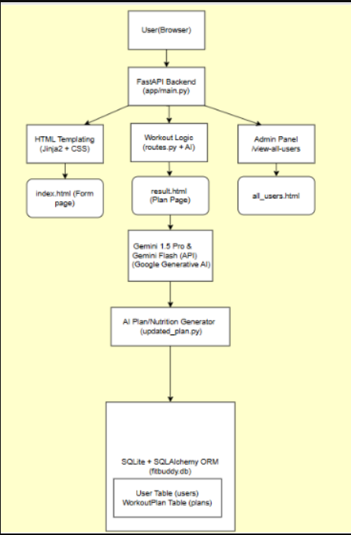
Pre-requisites:
FastAPI Framework Knowledge: FastAPI Documentation
Gemini API Familiarity: Google Generative AI Documentation
HTML, CSS, and Jinja2 Template Skills: W3Schools HTML/CSS/Jinja2 Tutorials
Python Programming Proficiency: Python Official Docs
Version Control with Git: Git Documentation
SQLAlchemy and SQLite Basics: : SQLAlchemy Docs
Environment Setup (pip, virtualenv, or conda): Virtualenv Guide
Uvicorn ASGI Server: Uvicorn Docs
Project workflow:
Milestone 1. Model selection and Architecture
Activity 1.1. Research and Select the Appropriate Generative AI Model
Activity 1.2. Define the architecture of the application
Activity 1.3. Set up the development Environment
Milestone 2. Core functionalities Development
Activity 2.1. Develop the core functionalities
Activity 2.2. Implement the FastAPI Backend to Manage Routing and User Input Processing
Milestone 3. route.py Development
Activity 3.1. Writing the Main Application Logic in routes.py
Milestone 4. Frontend Development
Activity 4.1. Designing and Developing User Interface
Activity 4.2. Creating Dynamic Templates with FastAPI’s Jinja2
Milestone 5. Deployment
Activity 5.1. Preparing the Application for Local Deployment
Activity 5.2. Testing and Verifying Local Deployment
Epic 1: Model selection and Architecture
Description
In this milestone, we focus on selecting the appropriate generative AI models from Google’s Gemini family for the FitBuddy application. This includes evaluating the performance and capabilities of multiple Gemini models to ensure they align with the application’s core functionalities—such as generating personalized workout plans, updating them based on feedback, and providing tailored nutrition or recovery advice.
Activity 1.1: Research and Select the Appropriate Generative AI Model
Description
Understand the Project Requirements
FitBuddy’s AI model needed to:
Generate structured 7-day workout plans
Provide concise and actionable nutrition tips
Update workout plans based on user feedback
Perform well in real-time, web-based interaction
Model Evaluation
We initially experimented with several Hugging Face models:
T5 & BART – For text generation (workout/nutrition)
DistilBERT – For potential intent classification
Bloom – For general purpose generation
While these models showed promise in basic text generation, they had notable limitations.
These models required:
Hosting with Hugging Face or local GPU setup
Fine-tuning or complex prompting to achieve structured plans
Final Model Selection
After comparative testing, we selected Google Gemini models for production:
Gemini 1.5 Pro
→ Used for structured 7-day workout generation and plan updating
→ Delivers rich, context-aware, formatted responses reliably
Gemini Flash
→ Used for generating fast, practical nutrition tips
→ Lightweight and efficient for quick API calls
Reasons for Choosing Gemini:
API-based, easy to integrate with FastAPI
Naturally understands structured formatting (days, sections)
High accuracy with minimal prompt tuning
Scalable and fast for feedback-based revisions
Activity 1.2. Define the architecture of the application
Architecture Overview: FitBuddy follows a modular FastAPI-based architecture-
Frontend: HTML + Jinja2 templates for user input and display
Backend: FastAPI for route handling and logic
AI Layer: Google Gemini APIs (Pro & Flash)
Database: SQLite with SQLAlchemy for persistence
Frontend Responsibilities: Users interact via-
index.html – Input form
result.html – Plan, tip, feedback
all_users.html – Admin panel
Backend Responsibilities:
Receives form data
Calls Gemini models
Stores user info and plans
Renders dynamic templates
AI Integration Points:
Workout generation & feedback updates → Gemini Pro
Nutrition tips → Gemini Flash
Install Python & Pip: Ensure Python and pip are installed.
Create Virtual Environment:
python -m venv fitbuddy-env
fitbuddy-env\Scripts\activate (Windows)
Install Required Libraries:
pip install fastapi uvicorn jinja2 sqlalchemy python-multipart google-generativeai
Run Server:
uvicorn app.main:app --reload
Visit http://127.0.0.1:8000 for the app and /docs for API testing.
Set Up Project Structure:
Create folders: /app (Python files), /templates (HTML), /static/images (assets)
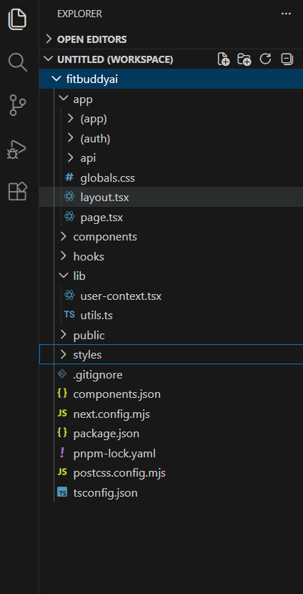

Epic 2: Core functionalities Development
Workout Plan Generation
Function: generate_workout_gemini()
File: gemini_generator.py
Implements the core logic to generate a personalized 7-day workout plan using user inputs such as goal (e.g., muscle gain, weight loss) and intensity (low, medium, high). The prompt is sent to the Gemini 1.5 Pro model, which returns a structured, day-wise plan including:
Warm-up (5–10 mins)
Main workout (exercise details, sets, reps)
Cooldown or recovery tip
The output is returned to routes.py and rendered on the result.html page using <pre> blocks for formatting.
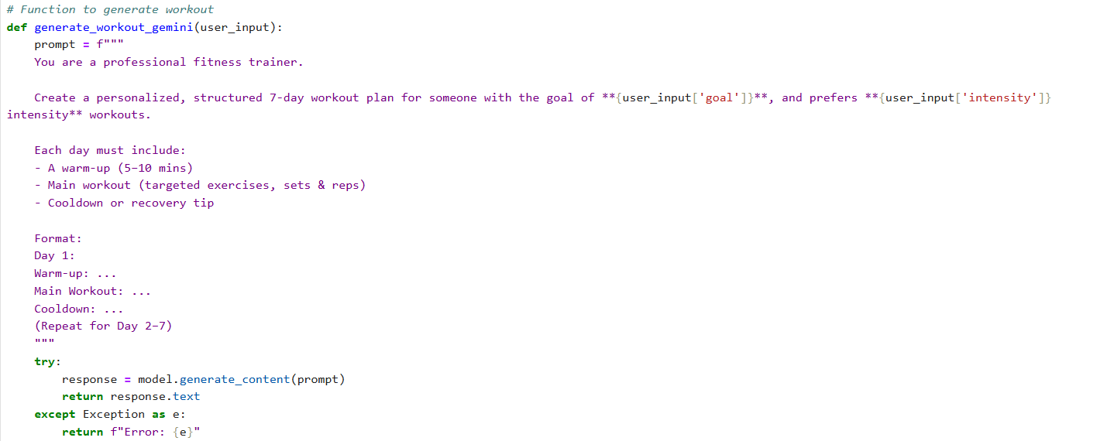
Activity 3.1: Writing the Main Application Logic in routes.py
Description
This Epic 3 focuses on building the routing logic inside the routes.py file, which acts as the core operational layer of the FitBuddy application. It bridges the frontend templates, AI generation modules (Gemini Pro and Flash), and the SQLite database. Each route defines how user inputs are collected, processed, and responded to — creating a dynamic, personalized experience for fitness planning and feedback-based updates.
Epic 4:Frontend development

Description

The frontend of the FitBuddy application focuses on creating a simple and user-friendly interface. It allows users to easily enter their personal details such as age, weight, fitness goal, and workout intensity. The interface is designed using HTML, CSS, and basic JavaScript to ensure smooth interaction.
The frontend communicates with the backend system to send user inputs and receive the generated fitness plan. It also displays the 7-day workout plan and nutrition tips clearly so users can follow them easily. The goal of the frontend is to provide a clean and accessible experience for users of all fitness levels.
Epic 5: Deployment
Description:
Deployment is the process of making the FitBuddy application available for users to access and use. After completing development and testing, the application is prepared to run on a server or online platform.
During deployment, the backend services, database, and frontend interface are connected properly so the system works smoothly. This step ensures that users can access the application, enter their details, and receive personalized fitness plans without any technical issues.
Conclusion:
The FitBuddy project demonstrates how Artificial Intelligence can be used to create personalized fitness plans for users. By using Gemini AI models, the system generates customized workout schedules and helpful nutrition tips based on user inputs.
The application provides an easy-to-use interface and efficient backend system, making it helpful for individuals who want to improve their fitness. Overall, FitBuddy shows the potential of AI technology in supporting healthier lifestyles.

